# Before setting up the systems

**Set up Google API key with distance matrix API**

1. Go to Google Cloud Platform and create a new credential > Then click “Restrict key”.

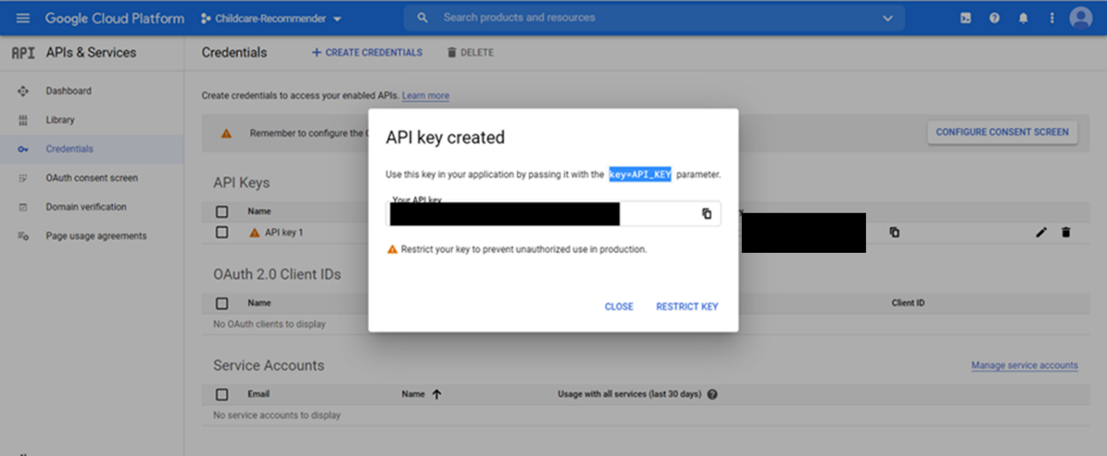

1. Select Distance Matrix API so that this key can only access this API. The purpose of this key is to enable distance matrix API only. If you also have any other keys that can access distance matrix API, can also use it for this project.

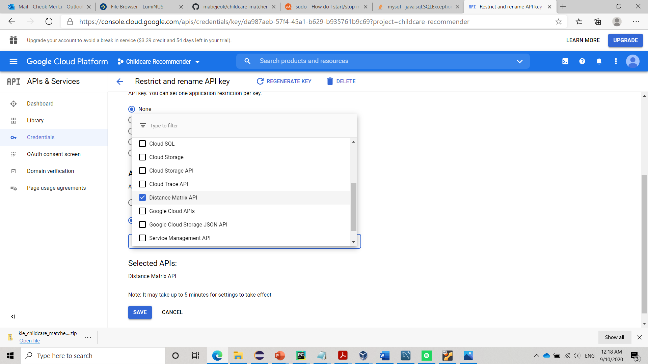

1. Download iss-vm and get it running. We will be using iss-vm for all the setup and use of our app.

# Set up the KIE system for childcare recommendation system

We have shell script for other processes, except this one because you will need to enter API key in the code. We recommend you set it up in Eclipse for easy entering of Google API key.

1. Download the zip file from <https://github.com/mabejeok/kie_childcare_matcher>
2. Extract the zipfile out to wherever you like. The extracted file name should be “kie_childcare_matcher-master”. For our guide, we extracted to /home/iss-user/Download
3. Open Eclipse and click on File from the top bar > Import > General > Existing Projects into Workspace then Browse… for the extracted file. In the picture below, my file location is in /home/Downloads/kie_childcare_matcher-master. Then click “Finish” button.

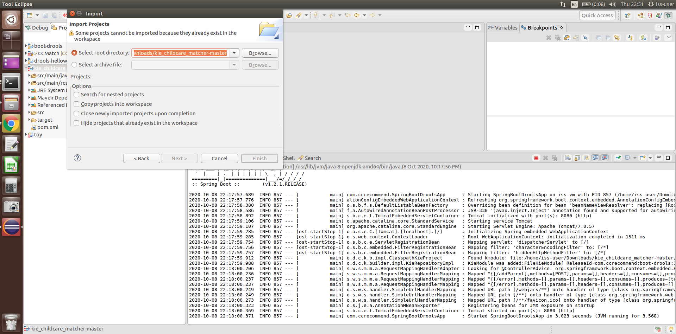

1. Please add in your Google API key here in Childcare.java

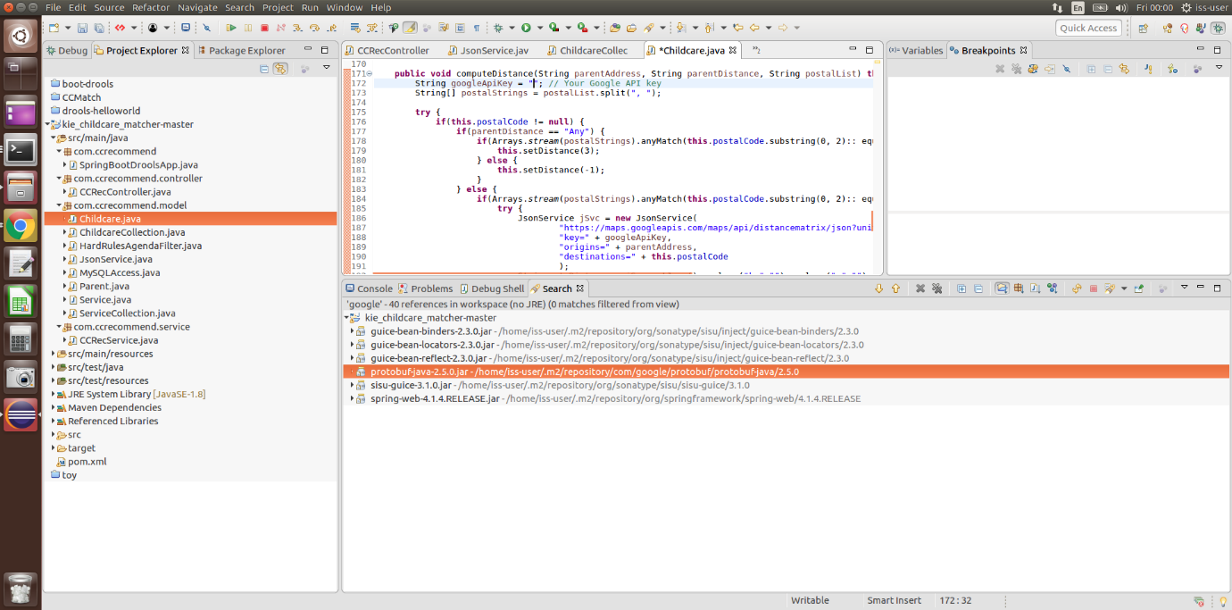

1. Now, we run the project! Go to the Run from the top bar > Run and you should see the “Spring” logo in Console.

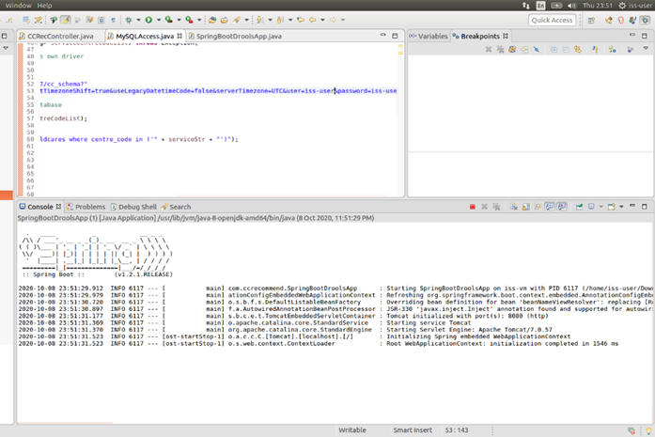

# Set up Python/Flask system for childcare recommendation system

Important: Please run this before setting up the childcare matcher system below, as the system requires the MySQL database which is set up here.

(If the following instructions did not work, please try the more detailed method below.)

1. Download the shell script from this [URL](https://github.com/mabejeok/IRS-PM-2020-11-01-ISY5001-GRP1-ChildcareMatcher/blob/main/System%20Code/mysql_python_rec_system.sh) or from IRS-PM-2020-11-01-ISY5001-GRP1-ChildcareMatcher GitHub project > SystemCode > mysql_python_rec_system.sh into /home/iss-user/Downloads
2. Open up a terminal in the above Downloads folder (so that the terminal can access the .sh file) and type and enter in “chmod 755 mysql_python_rec_system.sh”
3. Next run the shell script by typing “./mysql_python_rec_system.sh”
4. During the running of the shell-script, you will be prompted to enter password for sudo and mysql. Enter “iss-user” for password every time.
5. You will also be prompted to select the MySQL version. Tap Enter for this option

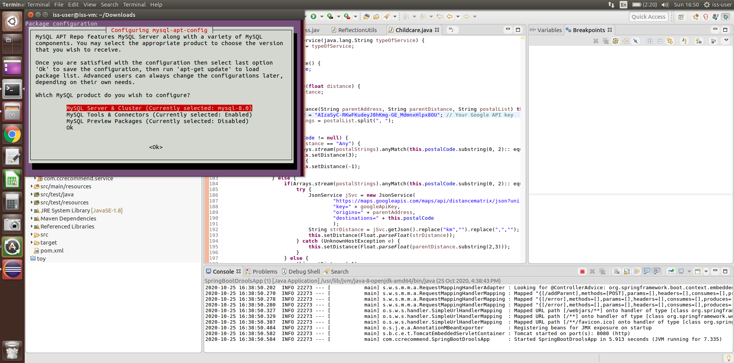

1. Next, you will see this option. Select mysql-8.0, by tapping Down key and tap Enter

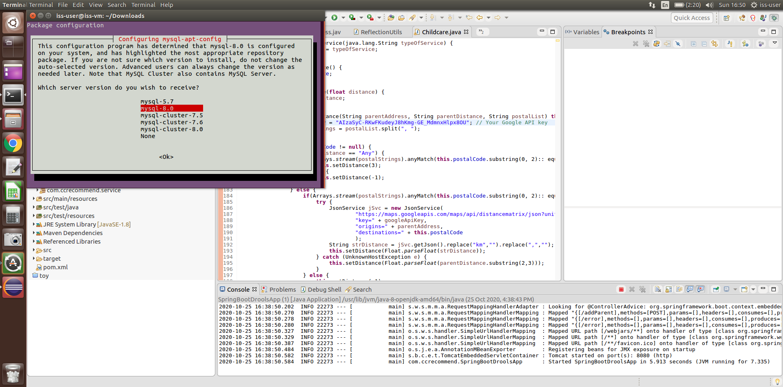

1. You will be prompted back to this window. Select Ok by tapping down key and tap Enter

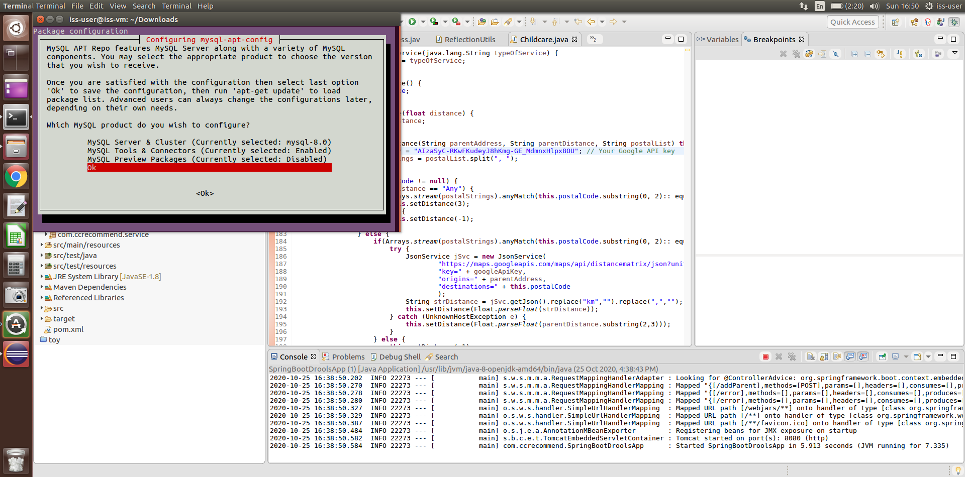

1. Once you see this, your Python/Flask server is running! You can access the system by going to <http://127.0.0.1:5000/> in Chrome or Edge browser.
2. You can stop by closing the terminal window.

# User guide for recommendation system

1. Choose a child birth date. The date is restricted to before today.
2. Choose an enrolment date. The date is restricted to after today.
3. The study level should auto-populate to a study level according to the birth and enrolment date. However, if the period between child birth date and enrolment date is bigger than 6, the study level will just revert to “Infant” because childcares cannot accommodated children more than 6 years old.

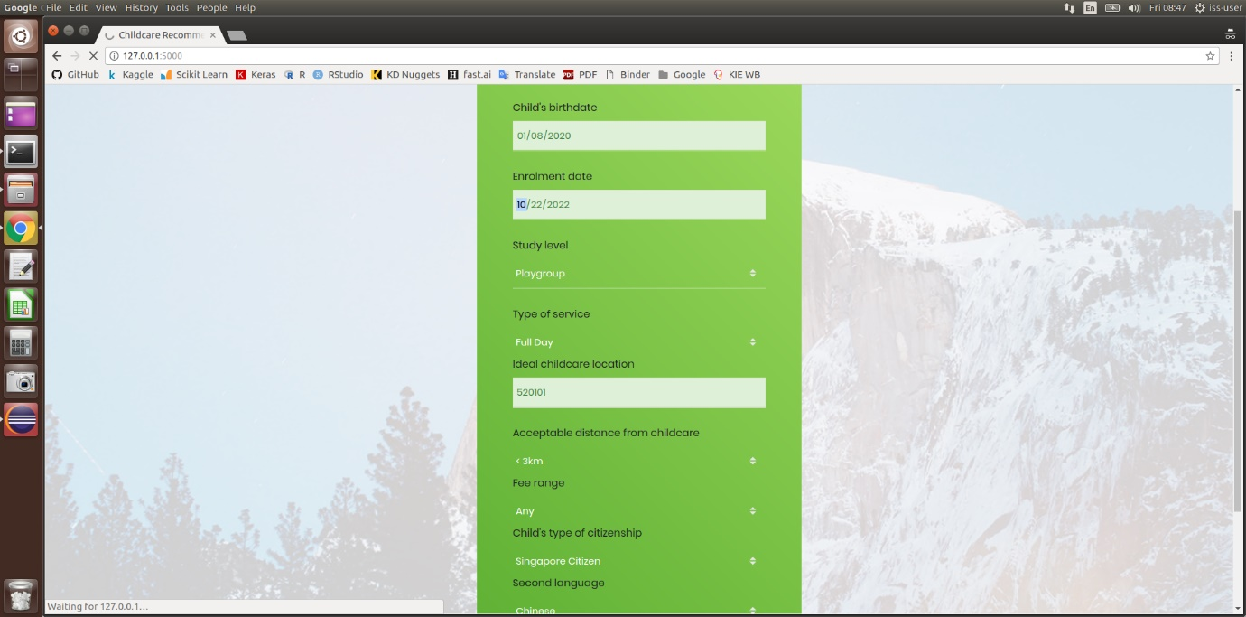

1. Choose whatever else you like and wait for it, look at the spinner at the tab (see image above).
2. If your requirements cannot be fully met, we will try to look for other childcares. A “x” will be shown. Else, you will see a tick for those that fully meets requirements. You can click on the column headers to sort the column.

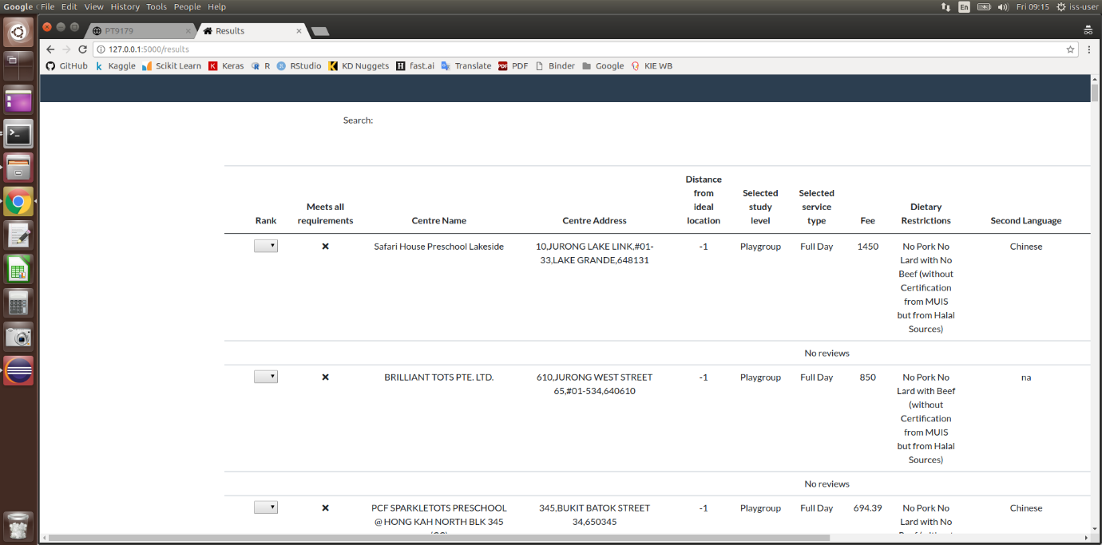

1. Add rank in the “Rank” column to the childcares you like. Please make sure the ranks are different from each other, if not an error will appear.

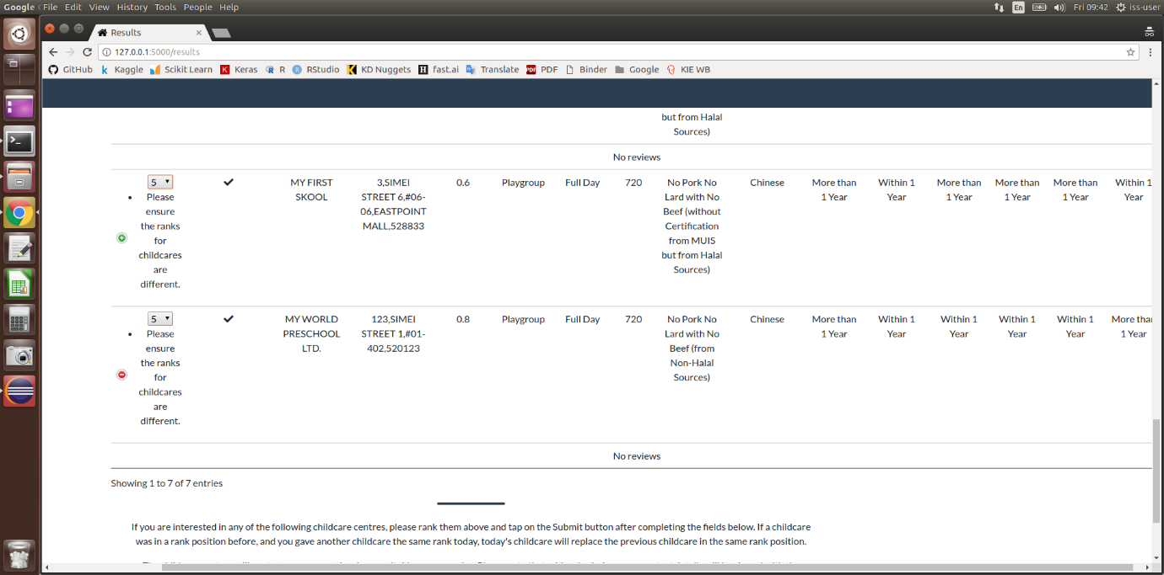

1. For some entries, we managed to scrape reviews and it will show below the entry. For reviews that are answers to a main comment, we currently cannot get the sentiment value for it, for the others a number will appear which is the sentiment score. If you think the table is annoying, you can close it by clicking on the red “-“ button, it will then change to green “+” button like above.

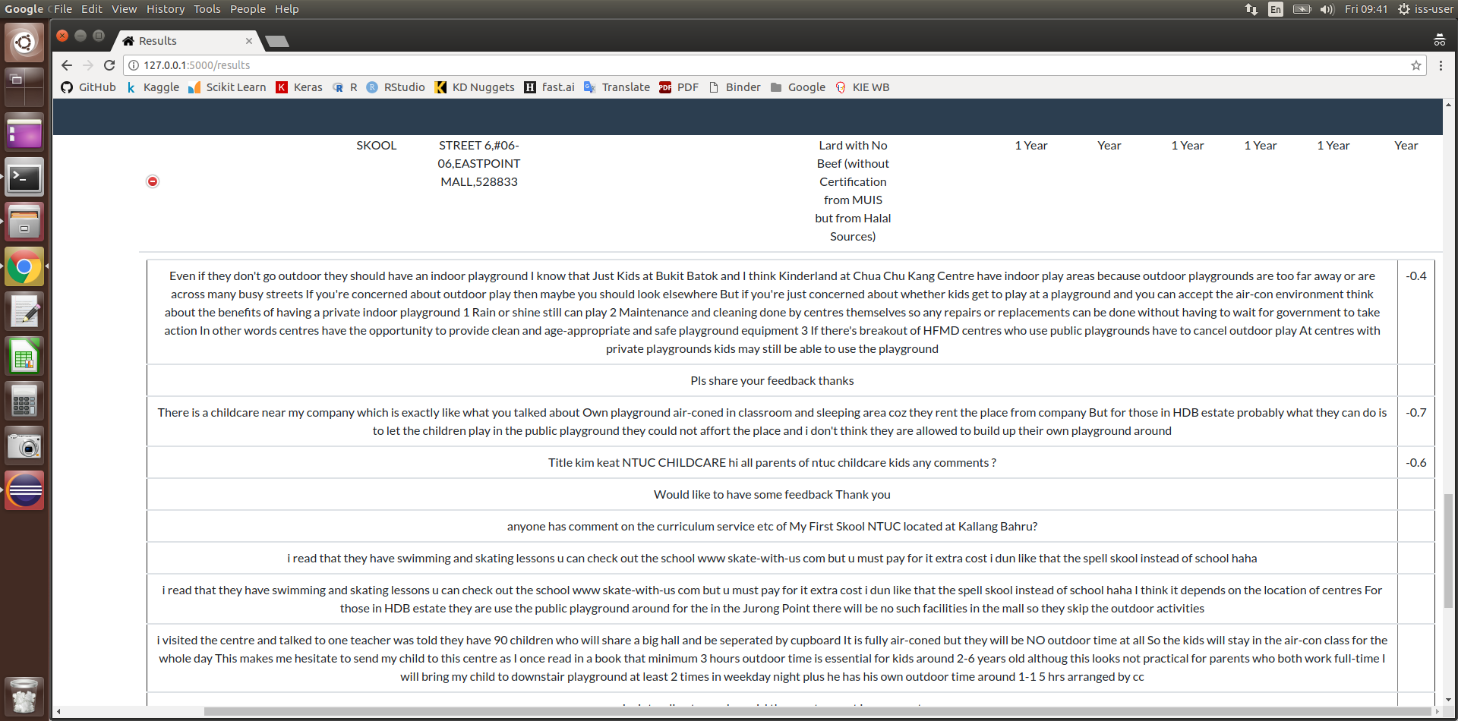

1. Now after we complete the form, we can submit our details.

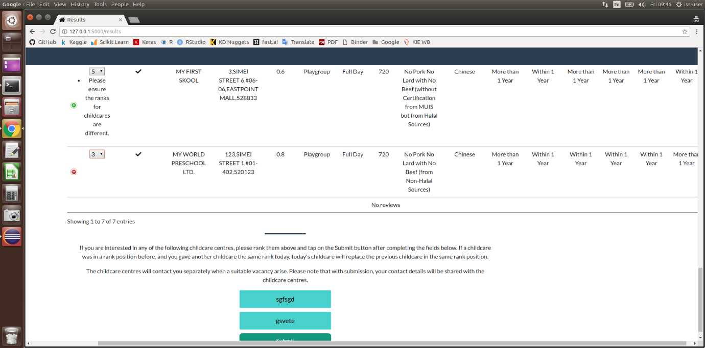

1. Tada! Check if your submission is correct.

# Set up childcare matcher for childcare centres

1. Please ensure that the Python/Flask system from childcare recommendation system is stopped.
2. Download the shell script from this [URL](https://github.com/mabejeok/IRS-PM-2020-11-01-ISY5001-GRP1-ChildcareMatcher/blob/main/System%20Code/python_cc_matcher.sh) or from IRS-PM-2020-11-01-ISY5001-GRP1-ChildcareMatcher GitHub project > SystemCode > python_cc_matcher.sh into /home/iss-user/Downloads
3. Open up a terminal and type and enter in “chmod 755 python_cc_matcher.sh”
4. Next run the shell script by typing “./python_cc_matcher.sh”

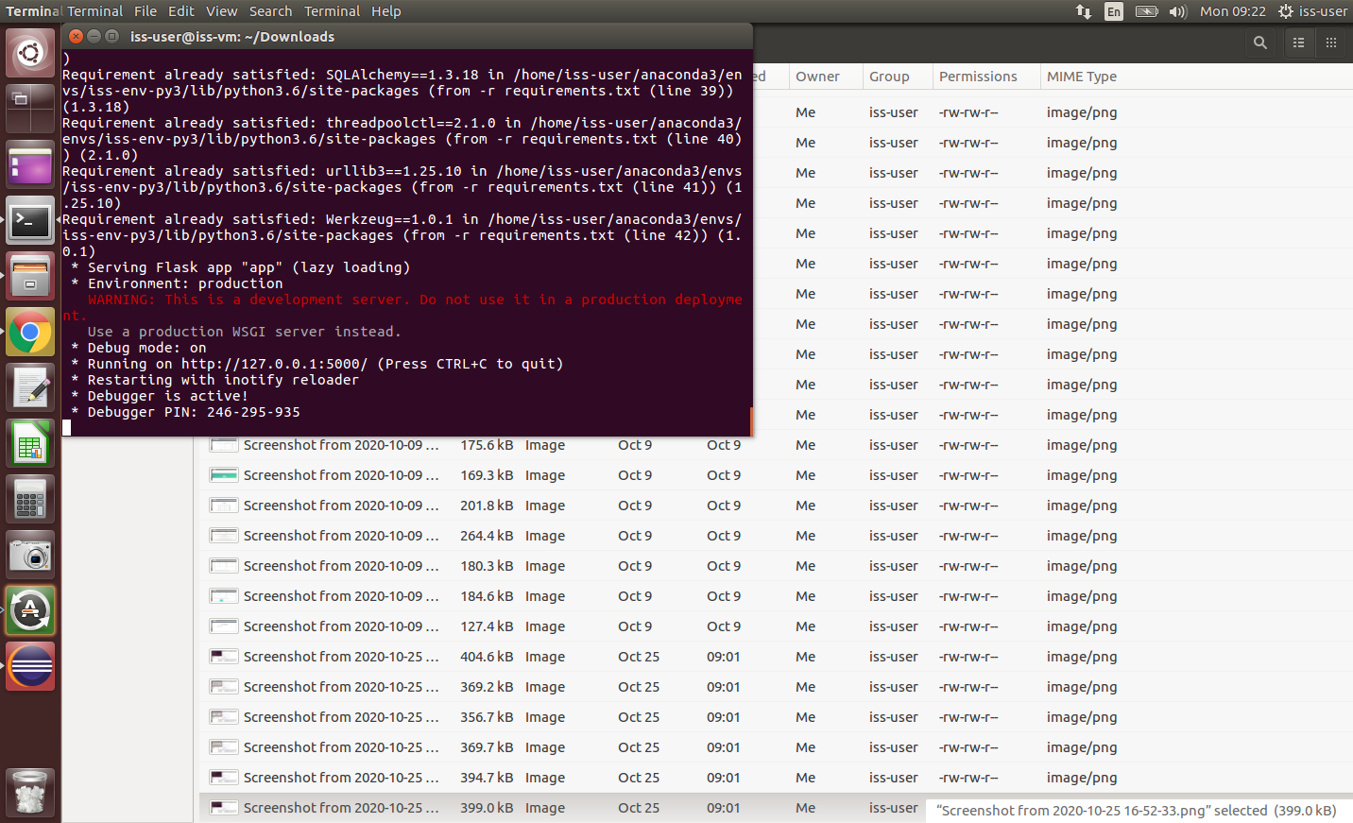

# User guide for childcare matcher

1. Sign in to childcare matcher with username “safari_house” and password “safari_house”. This is a single childcare’s account. If the credentials are wrong, an error will appear.

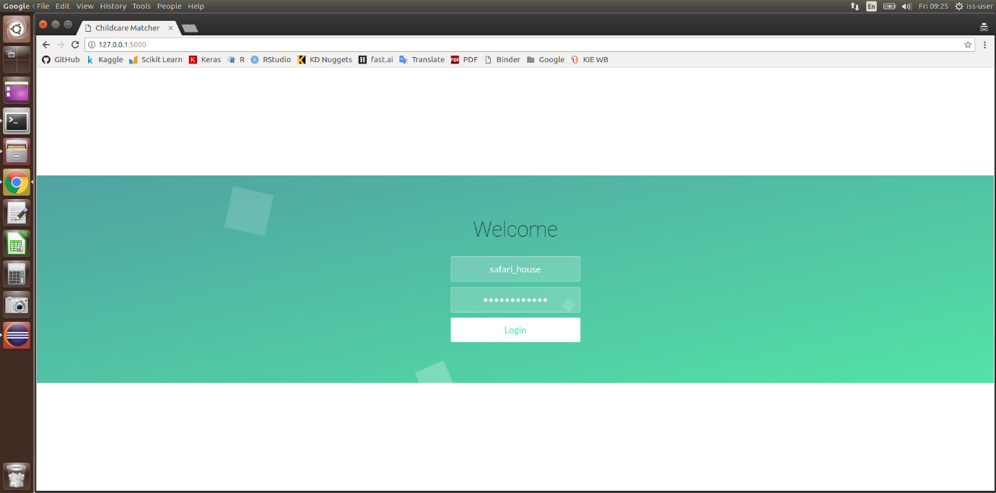

1. You will see the first rows without likelihood because these already have actions. You may see some rows with actions and likelihood, because those were predicted before action happened.

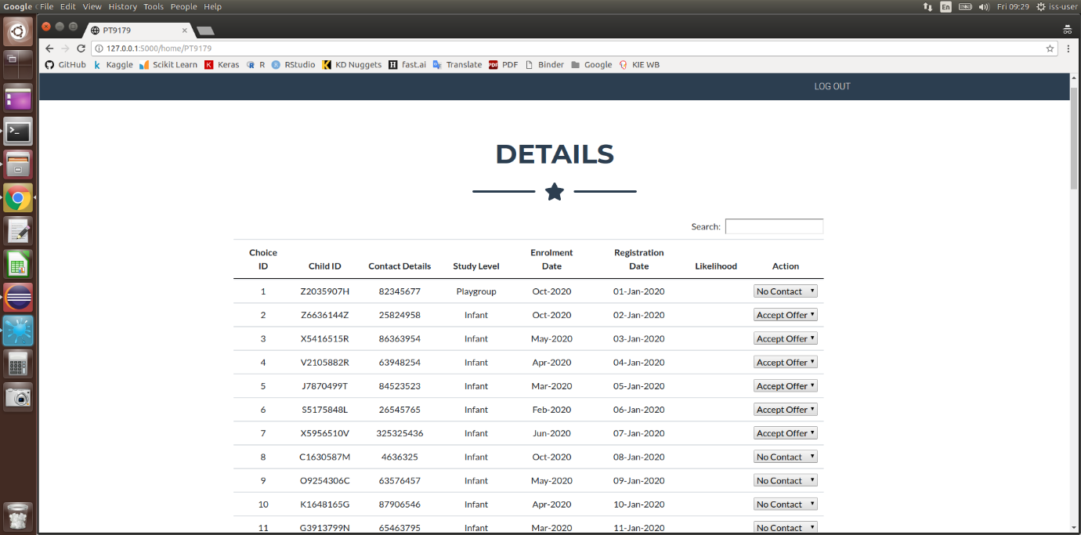

1. You can click on the columns to sort. Once you have the answer from the parent, “No Contact”, “Accept Offer” or “Reject Offer”, you can enter into the action column and submit for it to be committed to our database.

# Set up Python/Flask system for childcare recommendation (Alternative)

**Set up MySQL**

1. Within the virtual machine, follow steps in <https://computingforgeeks.com/how-to-install-mysql-8-0-on-ubuntu-linux/> until you see that the version installed in 8.0.19. This is to update the MySQL in iss-vm

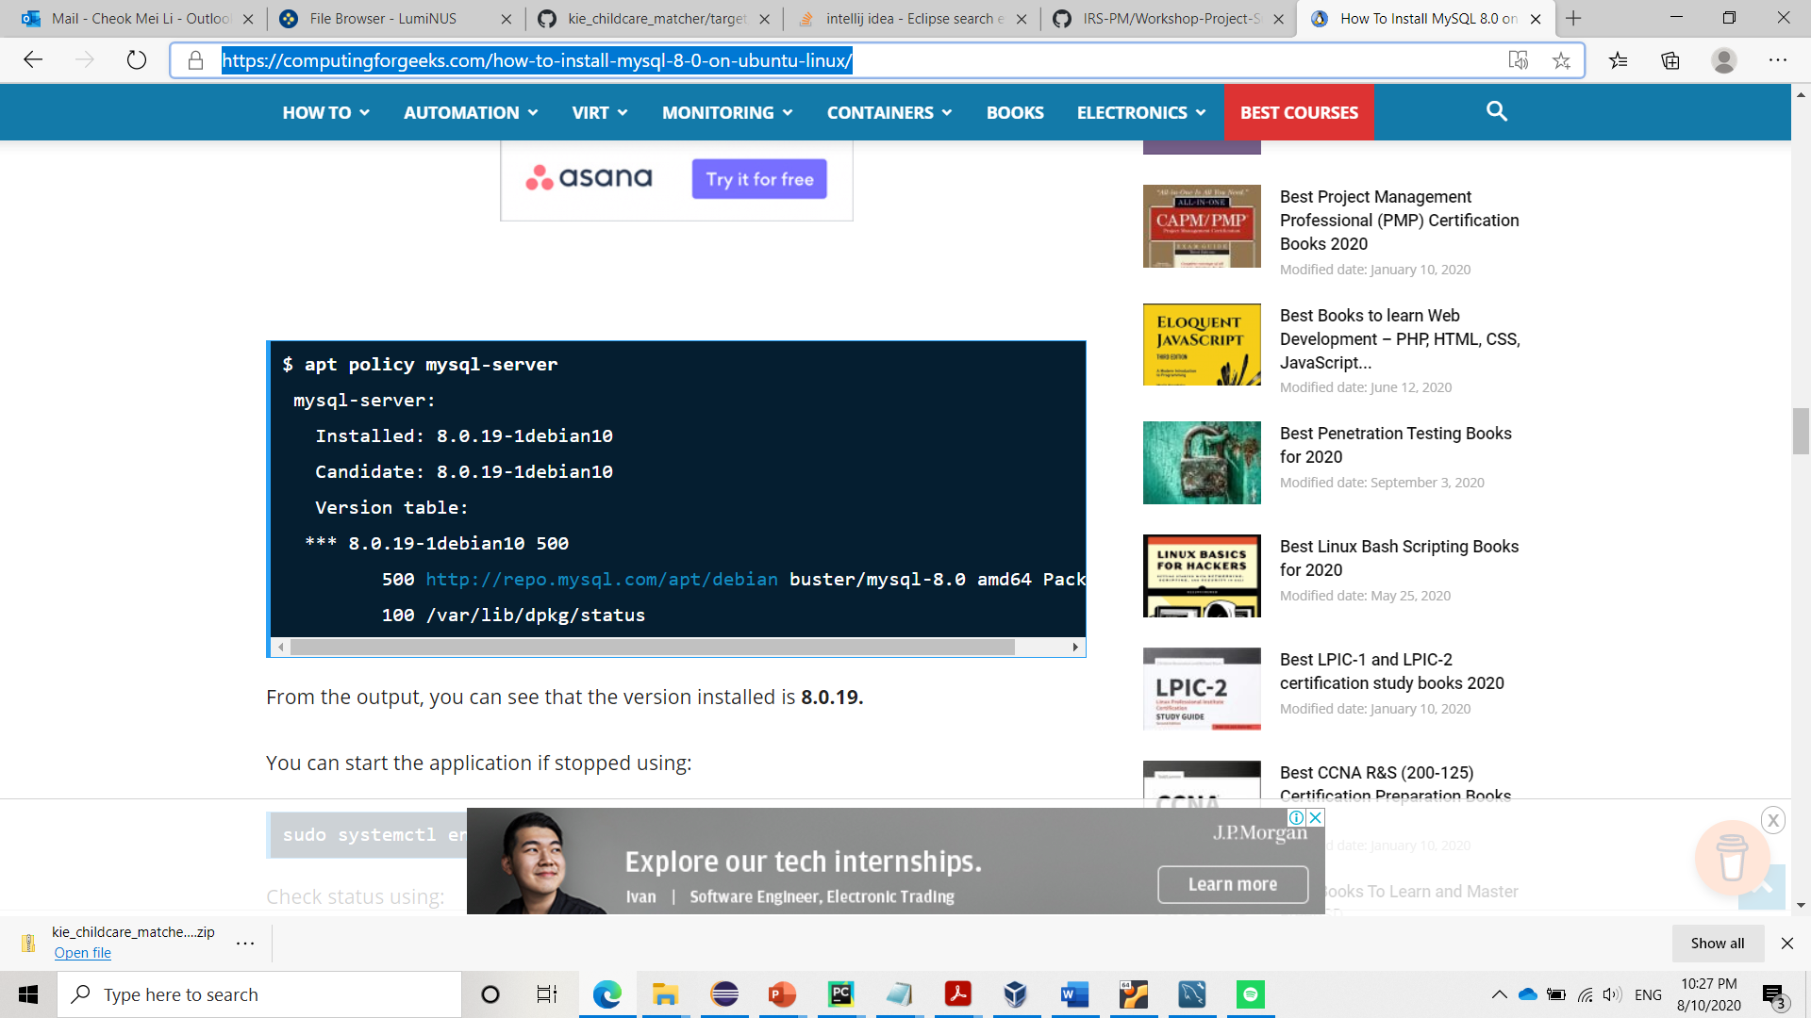

1. Open MySQL shell by double clicking on “Tool MySQL”

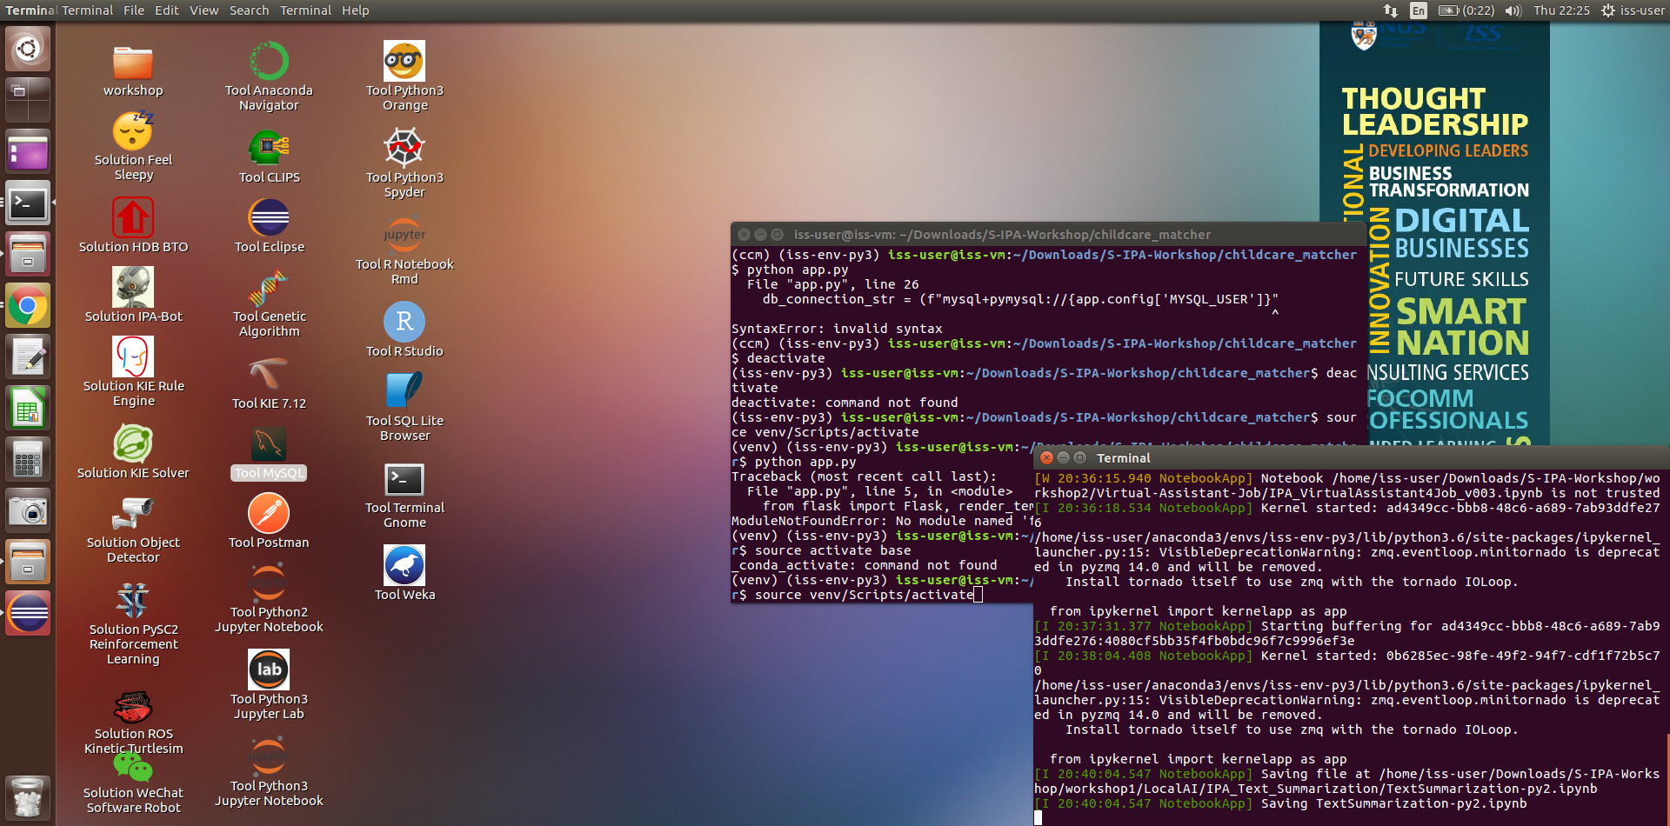

1. In MySQL shell, type in “create database cc_schema;”.
2. Next, type in “show databases;” to ensure cc_schema is created.
3. Download childcare_matcher.sql from <https://github.com/mabejeok/IRS-PM-2020-11-01-ISY5001-GRP1-ChildcareMatcher/tree/main/System%20Code> and put it in /home/iss-user
4. Then, go to a new terminal (command line, NOT the MySQL shell) and type in “mysql -u root -p cc_schema < /home/iss-user/Downloads/childcare_matcher.sql”
5. Now, go back to the MySQL shell and type in “use cc_schema;”. Then type in “show tables;” to ensure that these tables are in cc_schema.

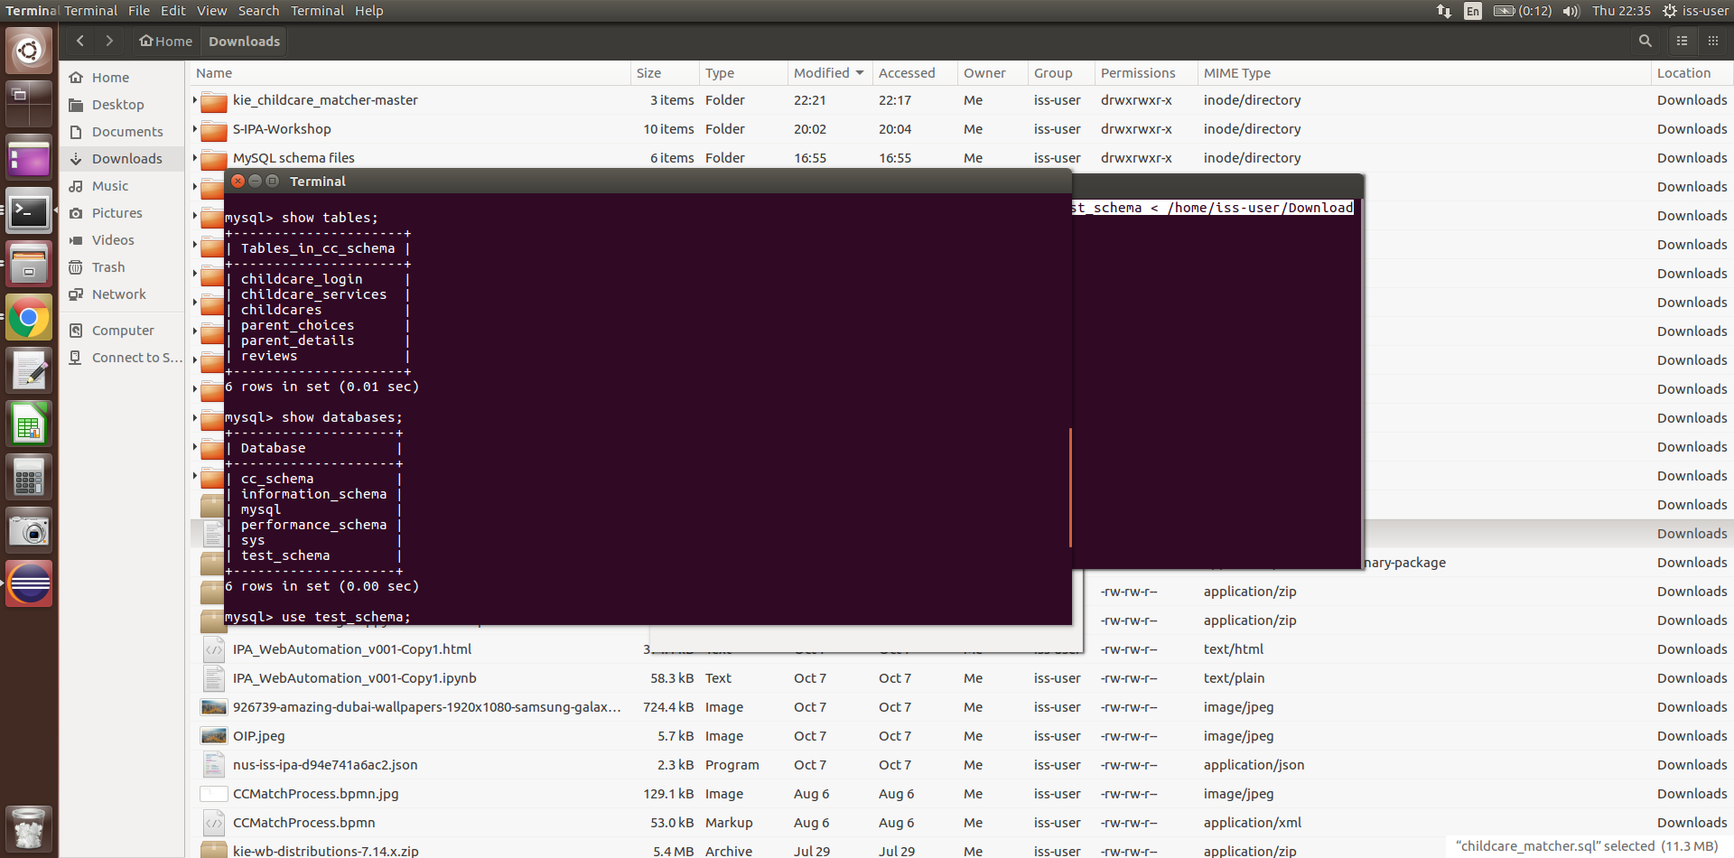

**Set up childcare recommendation system for parents**

1. Go to /home/Downloads and right-click, then select “Open with Terminal”

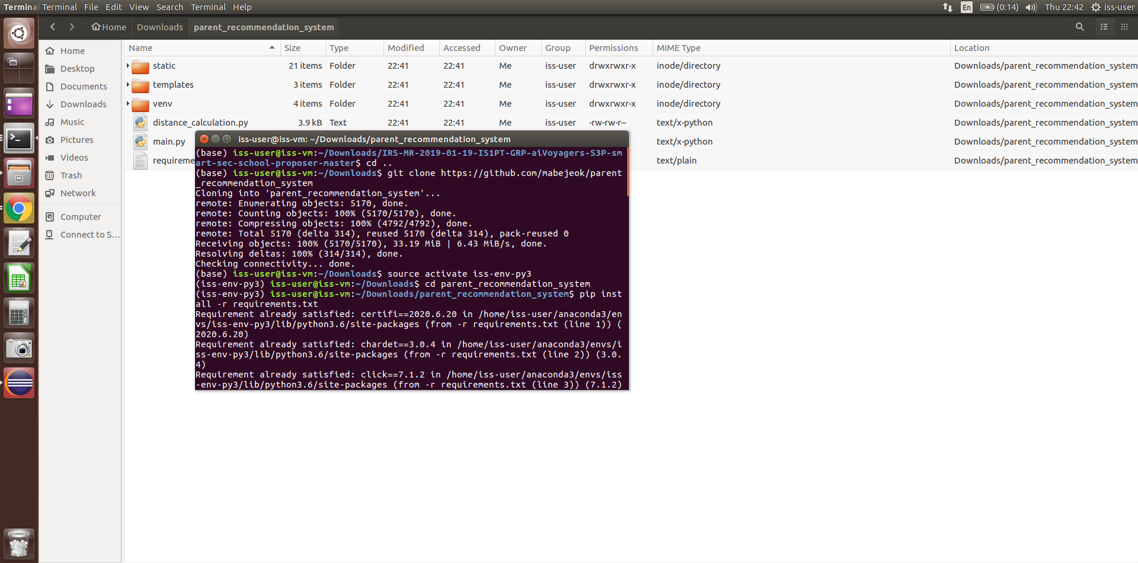

1. In the terminal window, type in “git clone <https://github.com/mabejeok/parent_recommendation_system>”
2. Then type “source activate iss-env-py3”
3. Then type “cd parent_recommendation_system”
4. Then type “pip install -r requirements.txt”
5. Lastly, type in “python main.py” and leave the server running.

# Set up childcare matcher for childcare centres (Alternative)

1. Go to /home/Downloads and right-click, then select “Open with Terminal”
2. In the terminal window, type in “git clone <https://github.com/mabejeok/childcare_matcher>”
3. Then type “source activate iss-env-py3”
4. Then type “cd childcare_matcher”
5. Then type “pip install -r requirements.txt”
6. Lastly, type in “python app.py” and leave the server running.